EXPERIMENT NO. 1
Name: Ishwari Deepak Kale
PRN: B26ET20083 Div: SY3 Class: C3

INPUT CODE:

#include<stdio.h>
int length(char[]);
void compare(char[],char[]); void palindrom(char[]); void substring(char[], char[]); void copy(char[],char[]); void reverse(char[]);
void displayMenu(); int i,j;
int main()
{
int choice; char str[50]; char str2[50]; int exit = 0;
displayMenu(); do
{
printf("ENTER CHOICE (7 for Display Menu): "); scanf("%d", &choice);
if(choice>=1 && choice<=6)
{
printf("Enter String: "); scanf("%s", str);
}

switch(choice)
{
case 1:
printf("Length of the String is %d\n\n", length(str)); break;
case 2:
printf("Enter second String: "); scanf("%s", str2);
copy(str, str2); break;
case 3:
reverse(str); break;
case 4:
palindrom(str); break;
case 5:
printf("Enter substring String: "); scanf("%s", str2);
substring(str, str2); break;
case 6:
printf("Enter second String: "); scanf("%s", str2); compare(str, str2);
break; case 7:
displayMenu(); break;
case 8:

exit = 1; break;
default:
printf("Invalid Choice!\n\n");
}
} while(exit == 0); return 0;
}
void displayMenu()
{
printf("<<-----------Menu >>\n"); printf("1. Length\n");
printf("2. Copy String in another String\n"); printf("3. Reverse String\n");
printf("4. Check for Palindrome\n"); printf("5. Check for Substring\n");
printf("6. Compare Any String with another\n"); printf("7. Display Menu\n");
printf("8. Exit\n\n");
}
int length(char a[])
{
int len = 0; while(a[len] != '\0')
len++; return len;
}
void compare(char str[], char str2[])
{
i = 0;

while(str[i] != '\0' && str2[i] != '\0')
{
if(str[i] != str2[i])
{
printf("Strings are NOT Equal.\n\n"); return;
}
i++;
}
if(str[i] == '\0' && str2[i] == '\0') printf("Strings are Equal.\n\n");
else
printf("Strings are NOT Equal.\n\n");
}
void palindrom(char a[])
{
int l = length(a); int flag = 1;
for(i = 0; i < l/2; i++)
{
if(a[i] != a[l-1-i])
{
flag = 0; break;
}
}
if(flag)
printf("The String is Palindrome.\n\n"); else

printf("The String is NOT Palindrome.\n\n");
}
void substring(char a[], char b[])
{
int al = length(a); int bl = length(b); int count = 0;
for(i = 0; i <= al - bl; i++)
{
for(j = 0; j < bl; j++)
{
if(a[i+j] != b[j]) break;
}
if(j == bl) count++;
}
if(count > 0)
printf("The String B is substring of A and occurs %d time(s).\n\n", count); else
printf("The String B is NOT substring of A.\n\n");
}
void copy(char a[], char b[])
{
i = 0;
while(b[i] != '\0')
{
a[i] = b[i]; i++;
}

a[i] = '\0';
printf("Original First String: %s\n", b); printf("Copied String: %s\n\n", a);
}
void reverse(char a[])
{
int al = length(a); printf("Reversed String: "); for(i = al-1; i >= 0; i--)
printf("%c", a[i]); printf("\n\n");
}

OUTPUTS:
- For input=1:
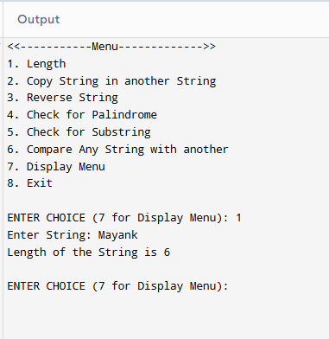
- For input =2:

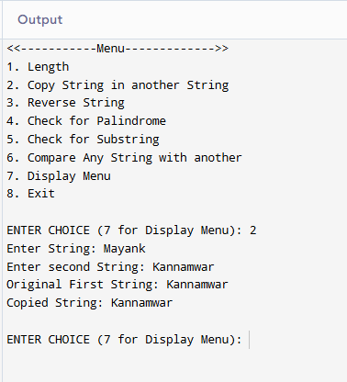
- For Input-3:
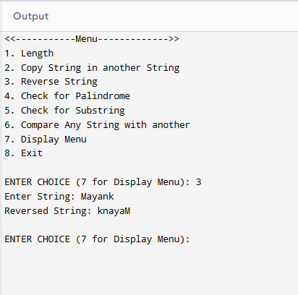

- For Input = 4 (When Pallindrome=True):
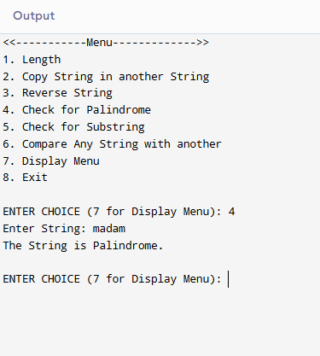
- For Input = 4 (When Pallindrome=False):
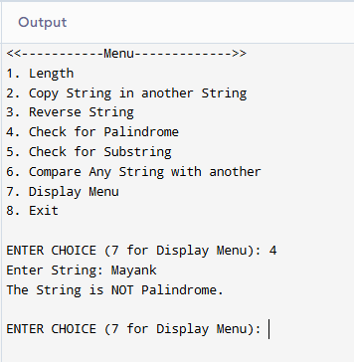

- For Input = 5 (When Substring is present):
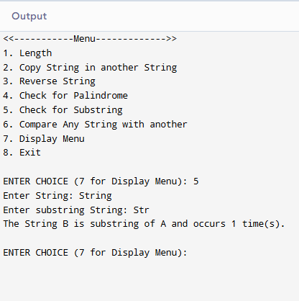
- For Input = 5 (When Substring is not present):
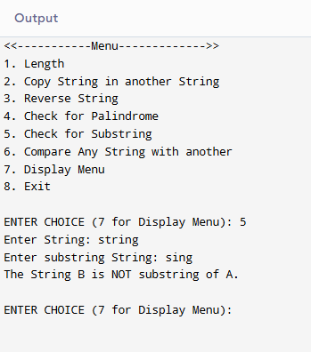

- For Input = 6 (When String are not equal):
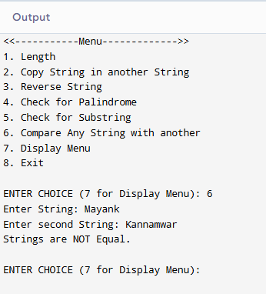
- For Input = 6 (When String are equal):
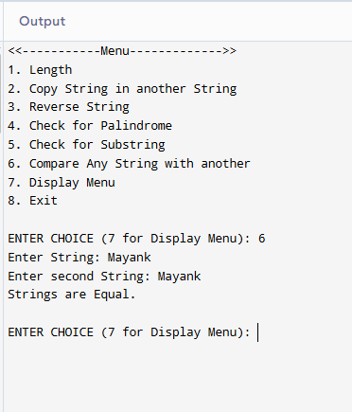
- For Input = 7:
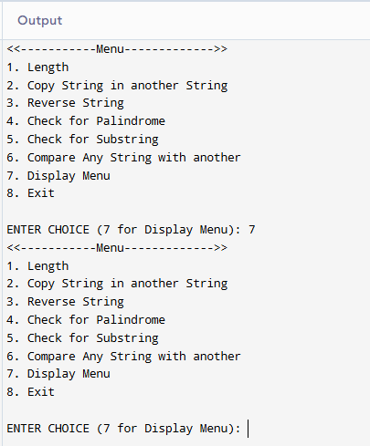
- For Input = 8:
